

**ST. JOSEPH’S COLLEGE FOR WOMEN, TIRUPUR**

**DEPARTMENT OF PHYSICS**

**Course Name: Data Analytics with Tableau**

**Academic Year: 2023-2024**

A project report entitled as

**“Insights into I Revolution: A Data-driven Exploration of Apple’s iPhone Impact in India with Tableau”**

Work done by

|  |  |  |  |
| --- | --- | --- | --- |
| **Univ. Reg.No** | **Naan Mudhalvan ID** | **Name** | **Class** |
| 2122C0133 | 11C343174753435A3CE45A9A04D0E616 | Anureshma.A | B.sc.,physics |
| 2122C0134 | BC36E1EEFEB0264860B470B2C1E85526 | Divya Dharshini.K | B.sc.,physics |
| 2122C0135 | 608B06255BC9EF4963A468812F4859E4 | Haasmina Fathima.S | B.sc.,physics |
| 2122C0137 | 24D8F8CDD8B4673B16240FB2528E3913 | Kavitha.S | B.sc.,physics |
| 2122C0138 | D1C48E1571C601C8DA44024E54CA79F2 | Maheswari.R | B.sc.,physics |
| 2122C0140 | 07C719FE1547846A1E34EFBF0E782F65 | Saranya.S | B.sc.,physics |
| 2122A0236 | 86C62AAFBB6DBCDB7F54B733050D1EAE | Gokilavani.R | B.sc.,mathematics |

**TEAM ID : NM2023TMID00388**

Under the guidance of

**Ms. S.K. Harini**

Assistance professor

**Department of physics**

**ST. JOSEPH’S COLLEGE FOR WOMEN, TIRUPUR**

**INBOX**

|  |  |  |
| --- | --- | --- |
| s.no | TITLE | PAGE NO |
| 1 | Introduction | 3 |
| 2 | Problem definition and thinking | 5 |
| 3 | Result | 7 |
| 4 | Advantage and Disadvantage | 13 |
| 5 | Application | 15 |
| 6 | Conclusion | 17 |
| 7 | Future Scope | 17 |
| 8 | Appendix | 18 |

**iRvolution: A Data-driven Exploration of Apple’s iPhone Imapact in India**

1.**INTRODUCTION**

When CEO Steve Jobs announced in January 2007 that Apple would be releasing a revolutionary iPhone five months hence, consumers waited with bated breath for a phone that would deliver all the features of their iPods as well as a smart phone. Anticipation grew, just as Jobs knew it would, as June approached. The launch would become one of the most heralded technological product splashes Apple, known for its masterful media build-up, had ever planned. How the iPhone was developed, priced, promoted, and distributed is lesson for marketers around the world. Apple investors were pretty happy with the outcome as well.

One year after Apple Inc. CEO Steve Jobs announced the company’s industrychanging iPhone on January 9, 2007, at the Macworld convention in San Francisco, the share price of Apple’s stock has more than doubled to a January 9, 2008, value of $179.40 (See Chart 1). This stock price incorporates all of Apple’s business, but a large part of the rise in value can be attributed to the launch of the cutting-edge iPhone, of which four million have already been sold through mid-January 2008 (Carew, 2008)

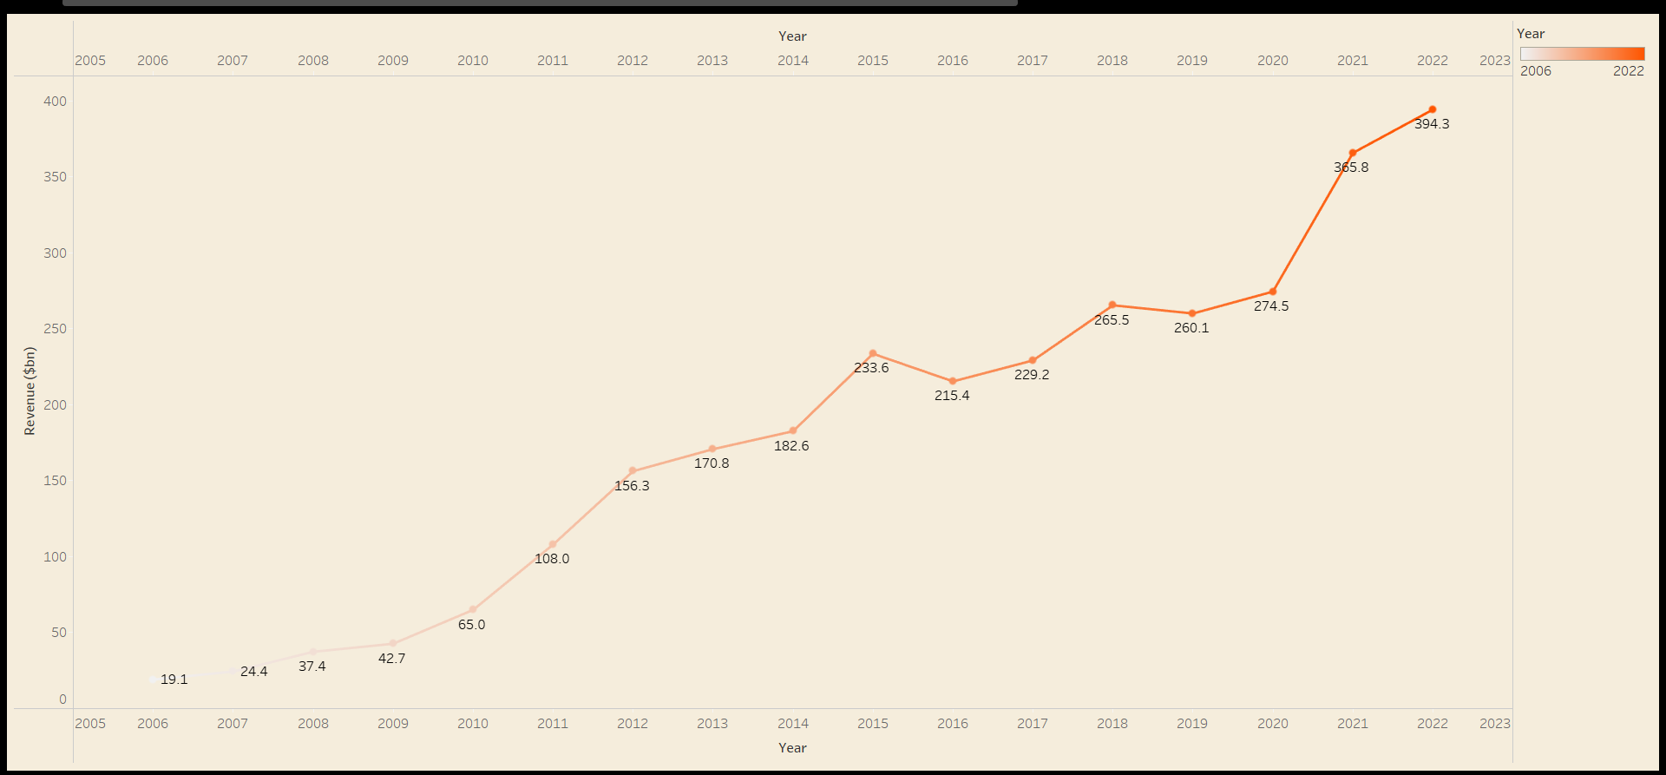

Based on this simple observation of the stock price, the iPhone can so far be declared a success, at least from a shareholder standpoint. This paper will explore both the preand post-launch activities surrounding the iPhone to explain why it was such a success for the stockholders and why Apple’s reputation for unparalleled marketing success is deserved.

1.2**PURPOSE**

* + The Wall Street Journal’s technology guru, Walter Mossberg, finally published his review of the iPhone only two days before its launch. Overall, he described the iPhone as a breakthrough handheld computer despite some shortcomings (Mossberg and Boehret, 2007).
  + The iPhone’s design is creating problems with some iPhone accessories.
  + For example, the headphone jack is deeply recessed on the multimedia device, meaning an adapter will be needed in order to use certain headphones with the iPhone.
  + Secondly, the device does not have the ability to cut, copy, and paste text, which could be extremely annoying if people are going to use the device to send and receive emails throughout their workday.
  + The iPhone is also missing instant messaging software, but it still has the ability to send and receive standard text messages.
  + Though the phone has a two-megapixel camera, it lacks the ability to record videos, a common feature on competing smart phones.
  + Finally, when the iPhone is first released it will not have the ability to play most video on the Internet because it does not utilize Adobe’s Flash technology.
  + Mossberg still has plenty of features to brag about on the iPhone, starting with the gorgeous 3.5- inch screen.
  + Most importantly, during the two-week test the device lacked any protection, and it never received a single scratch on the screen or on any other part of the device.

2**.PROBLEM DEFINITION AND DESIGN THINKING**

**2.1 EMPATHY MAP**

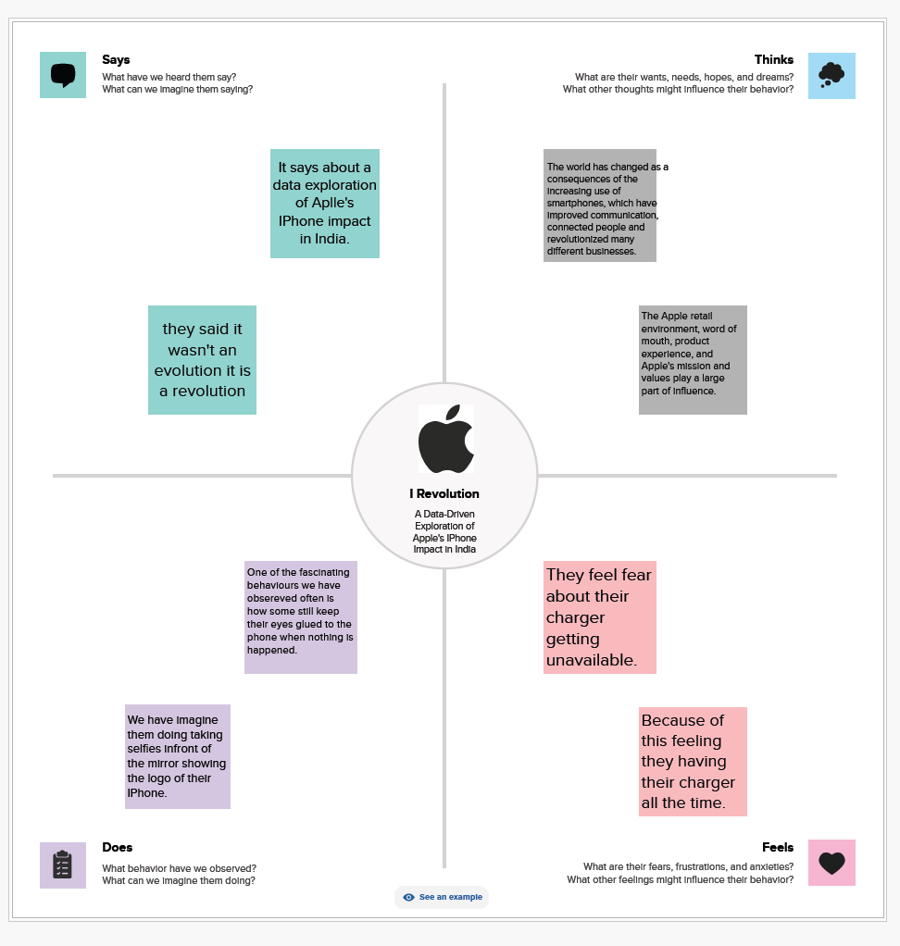

2.2 **IDEATION & BRAINSTROMING MAPPING**

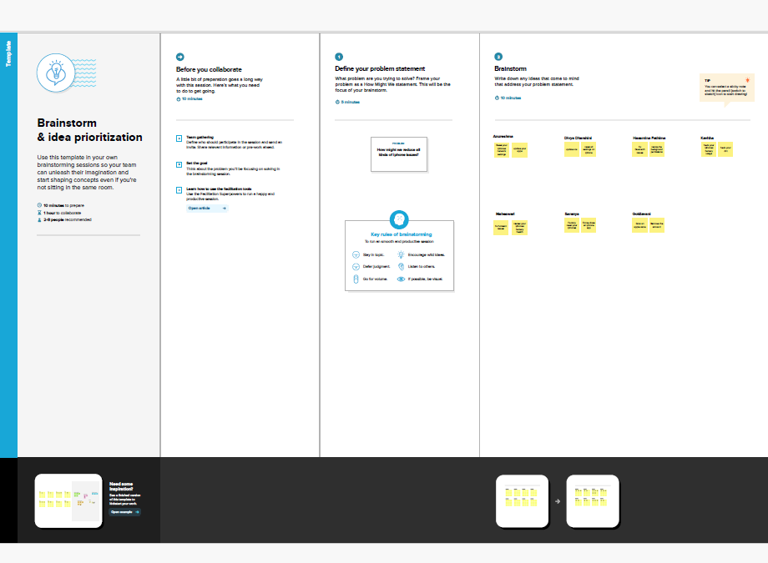 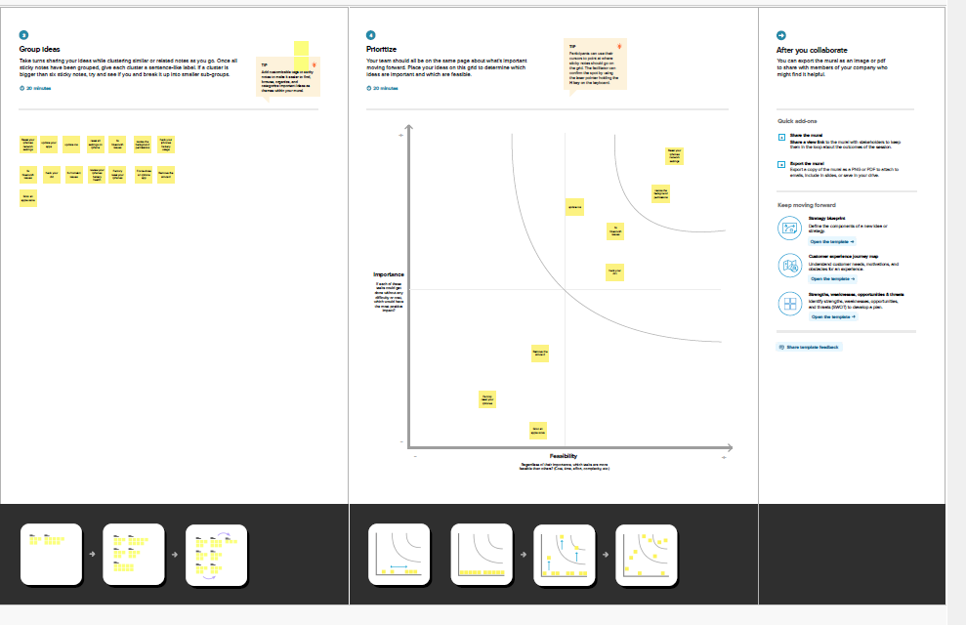

3**.RESULT**

DASHBOARD 1:

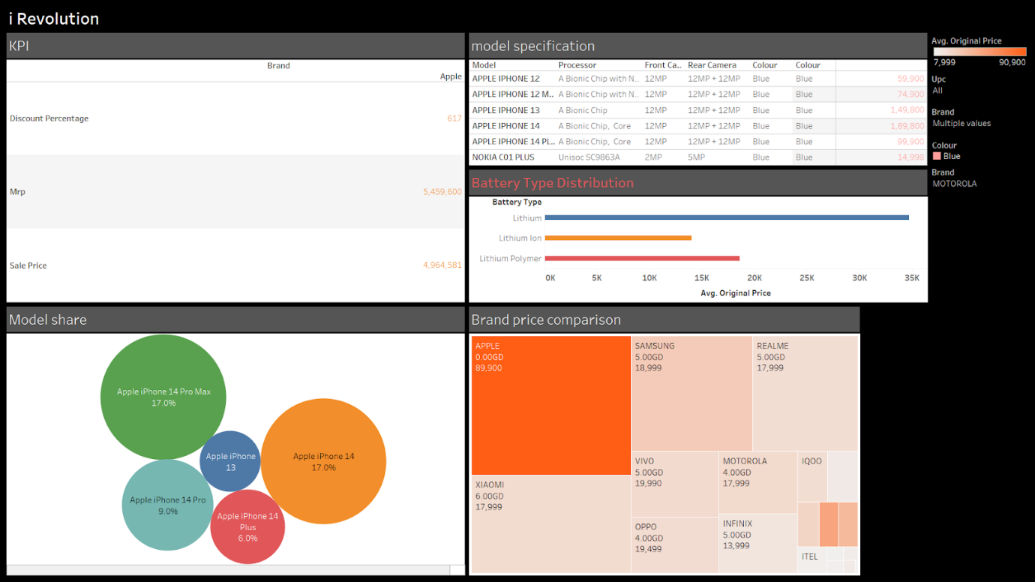

DASHBOARD 2:

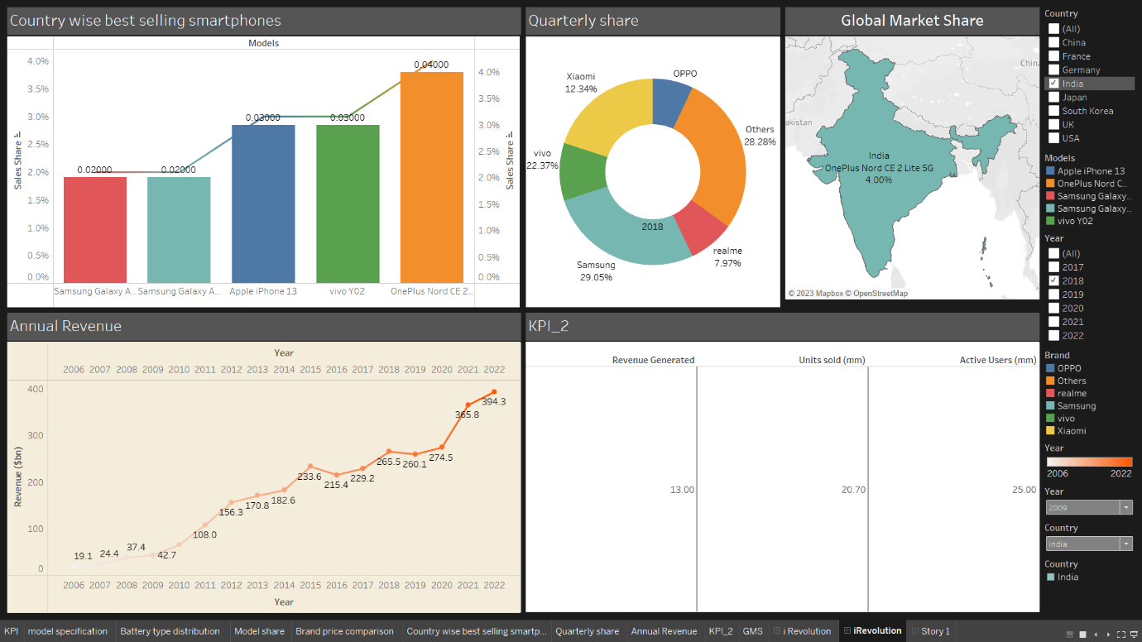

**STORY**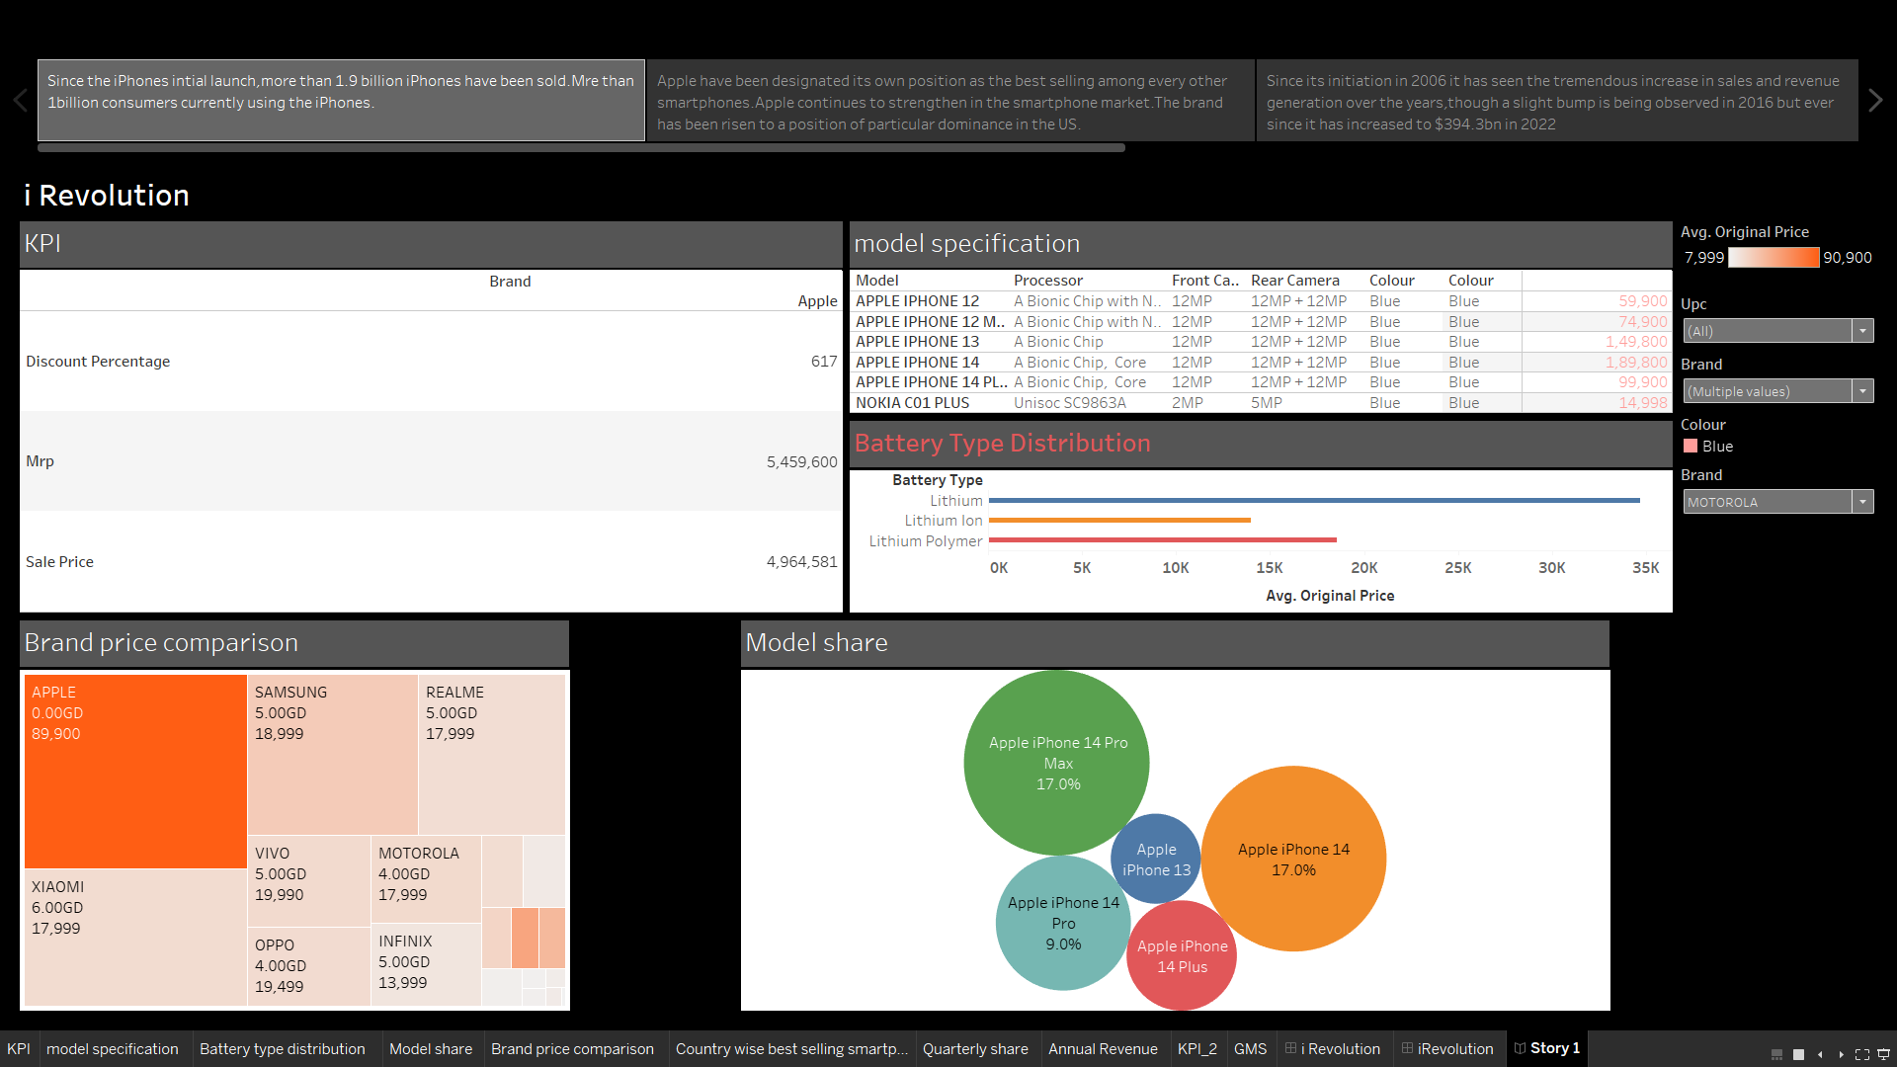

**VISUALIZATION**

**1.KPI**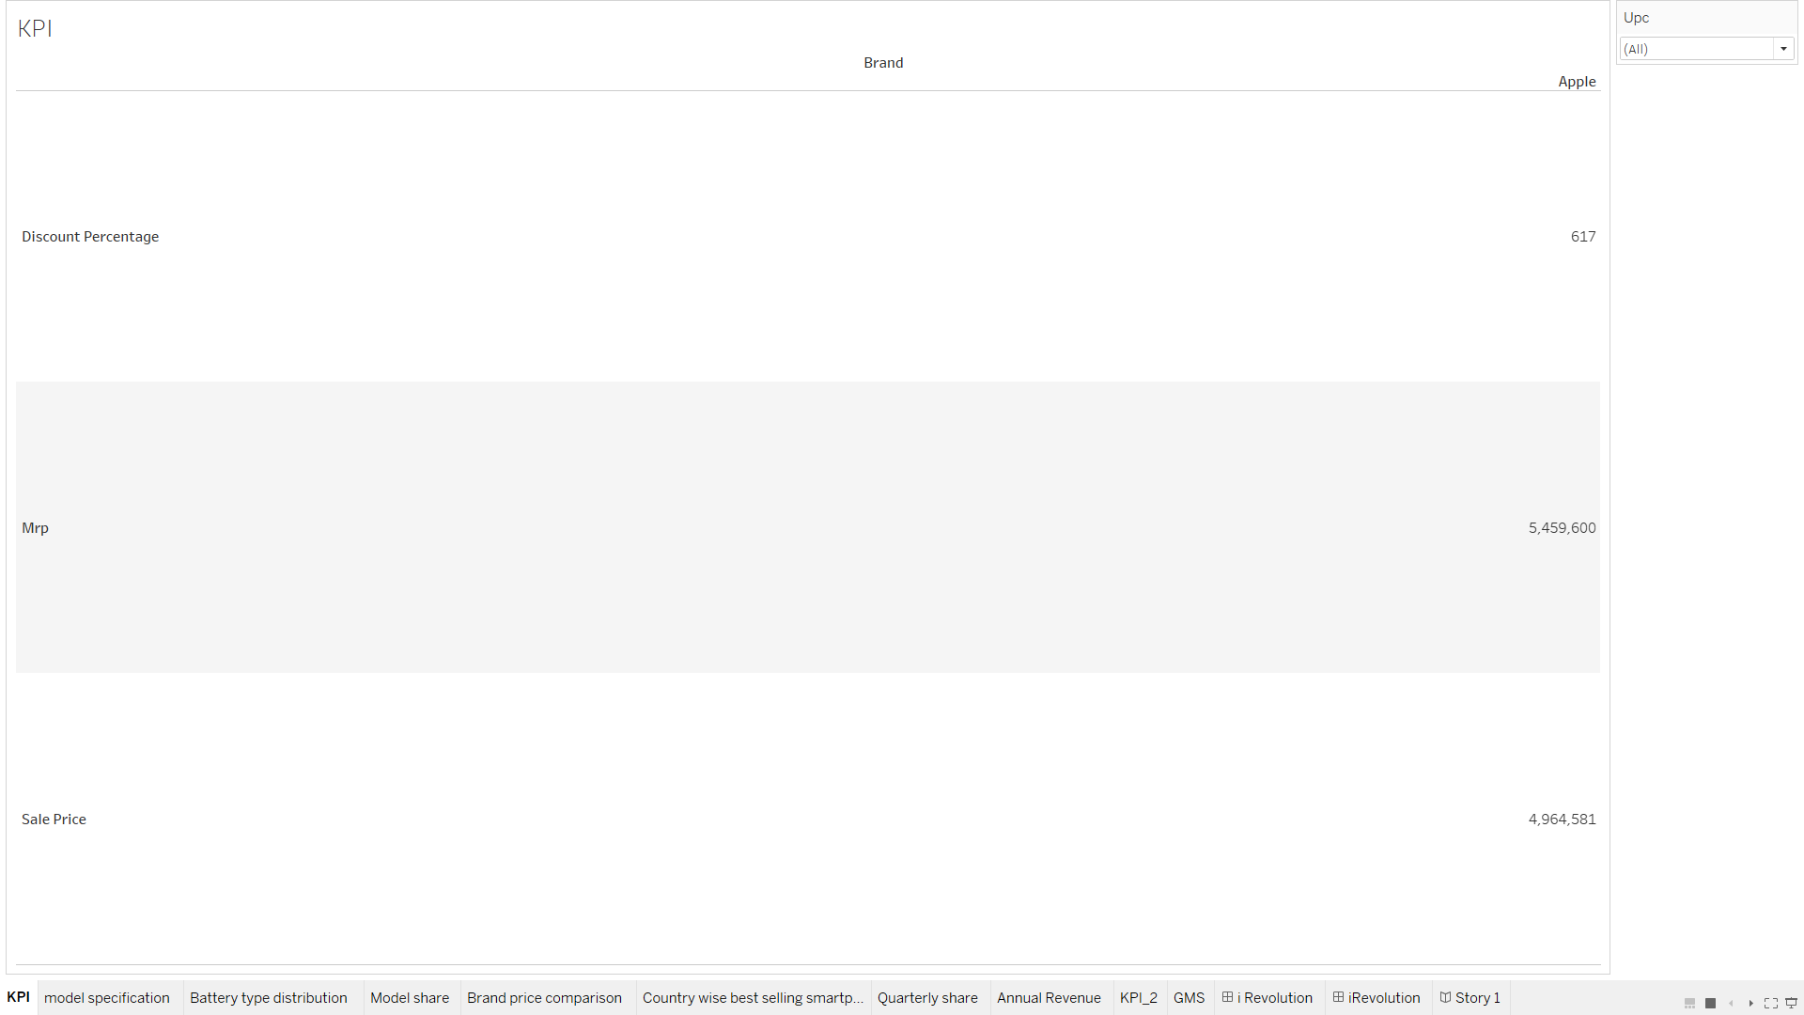

**2.MODEL SPECIFICATION**

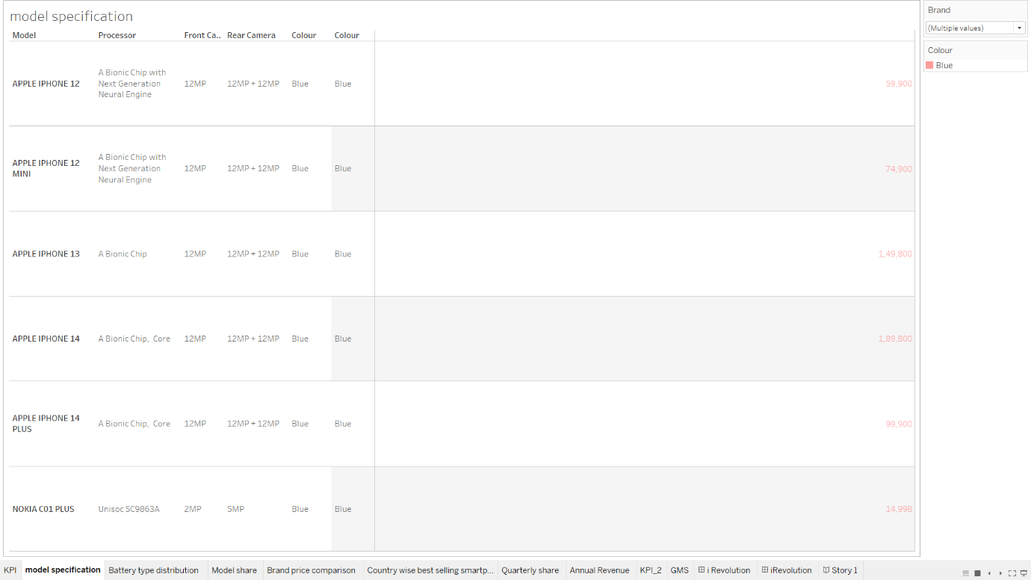

**3.BATTERY TYPE DISTRIBUTION**

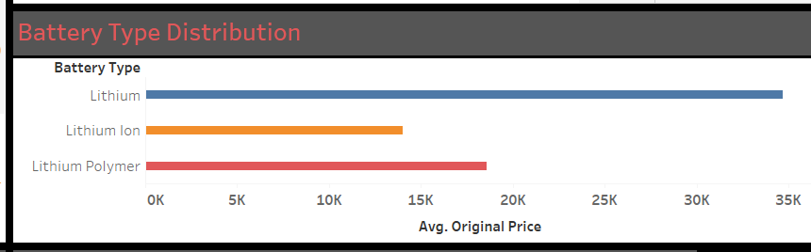

**4.BRAND PRICE COMARISON**

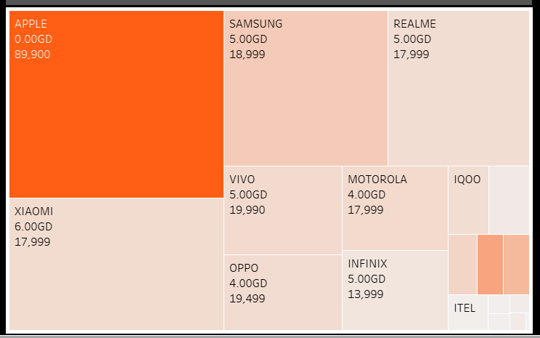

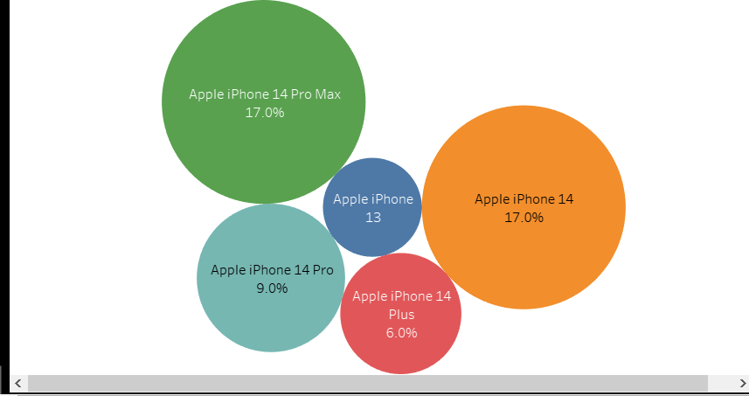**5.MODEL WISE SHARE OF IPHONE**

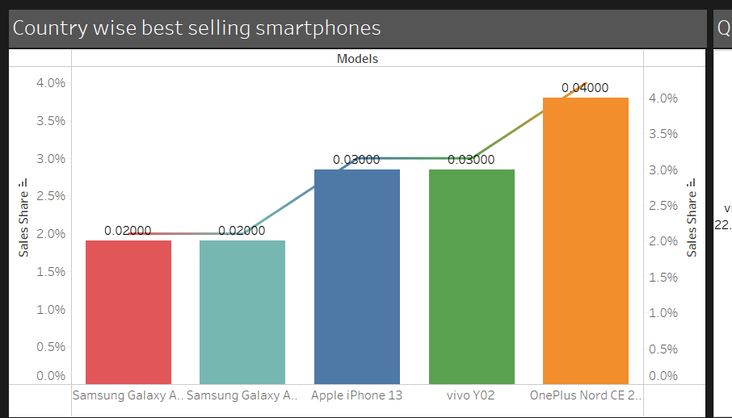**6. COUNTRY WISE BEST SELLING SMORTHONE**

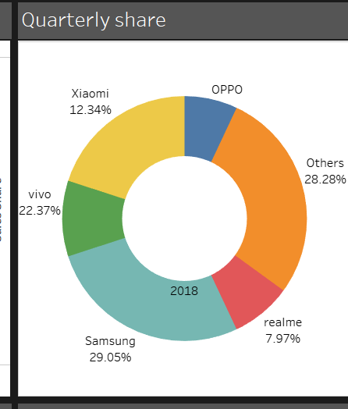**7.QUARTERLY-SHARE**

**8.ANNUAL-WISE REVENUE YEAR-WISE**

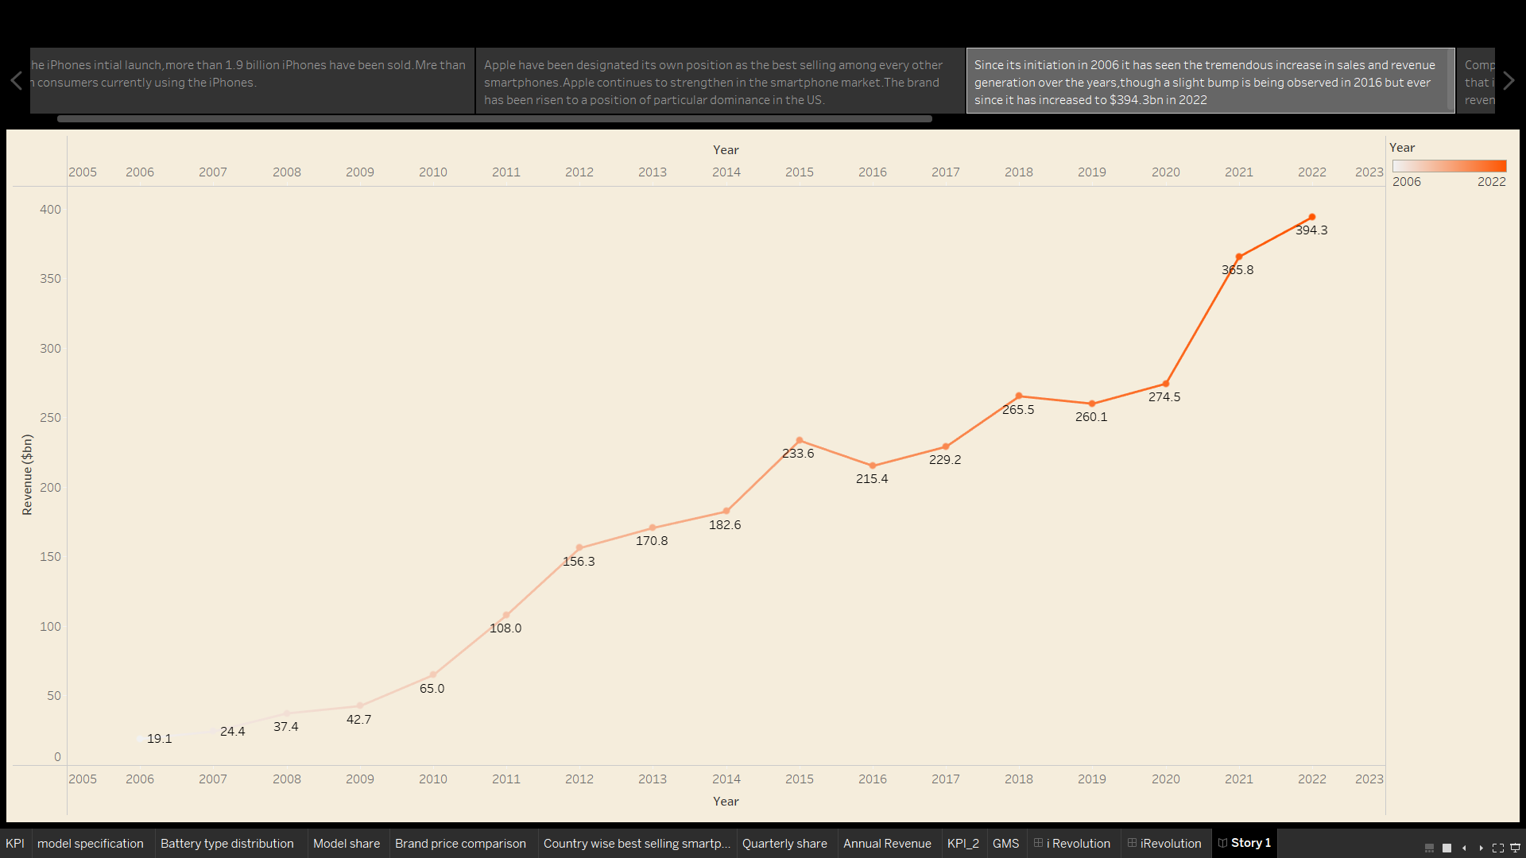

**9.KPI_2**

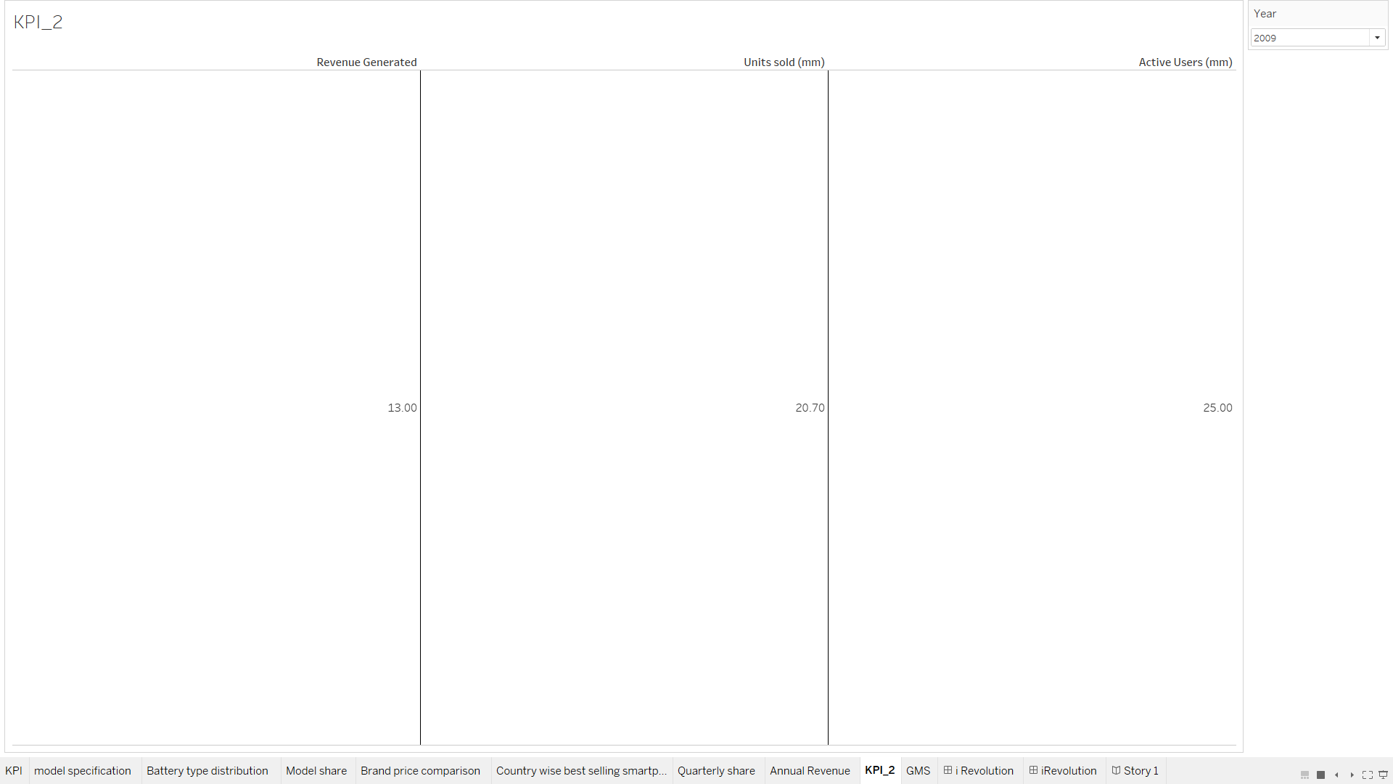

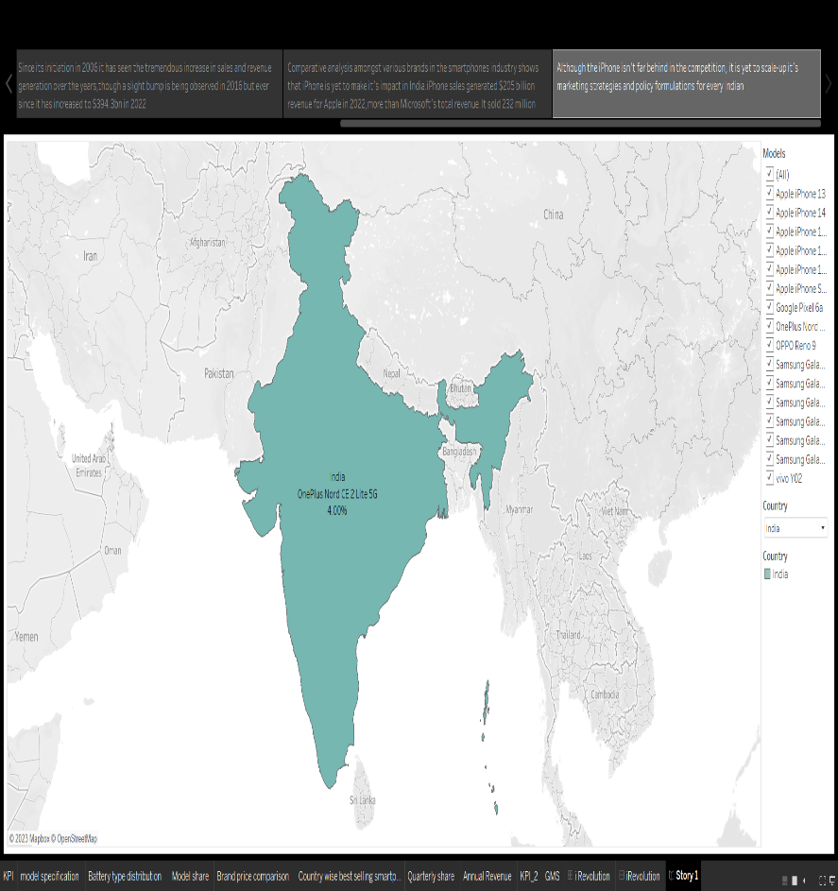**10.GLOBAL MARKET SHARE**

**4. ADVANTAGES AND DISADVANTAGES**

**4.1 ADVANTAGES**

One of the reasons that the idea, concepts and practice of data-driven culture has become such a sensation amongst so many innovative and forward looking companies and business establishments (Amazon, Netflix and T-Mobile to name a few), is quite simply the proven fact of its immense advantageousness to the various forms of organizational development.

An explicit listing of some of the more obvious benefits and advantages of a data-driven culture to organizations would include:

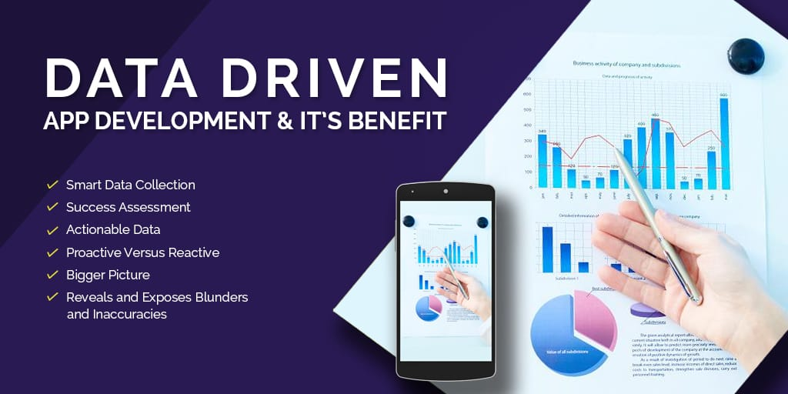

**1.Allows For First-Mover Advantage**

Data--and more importantly, its analytics--can help organizations respond to market changes faster. By harnessing data analytics, businesses can predict future trends, identify consumer behaviours and detect new business opportunities more quickly, creating the potential for obtaining significant market advantage.

**2. Grow Sales and Improve Processes**

Every business wants to maximize revenue growth. In a competitive global marketplace, data plays a crucial role in identifying and translating data into revenue opportunities. For example, slower sales growth can be a sign of mediocre sales team performance. By digging into the data, a leader can identify problems and develop sales and marketing strategies that can improve performance and grow revenues

**4.2 DISADVANTAGES**

* Apple increases the price of iPhones every year. iPhone is currently one of the most expensive smartphones out there usually due to its constantly updated physical appearance and tweaks made by engineers within the phone.
* Apple’s focus is on becoming more user-friendly, however, they turned out to be not so cost. Users are quick to complained about the iPhone price but are still so quick to purchase newly released iPhones.
* Even the older models that are still in use today have higher price compared to other smartphones.
* There is no getting around the price for those wanting an iPhone. iPhones comes with a storage range of 64 GB, 128 GB, 256 GB, 512 GB, and 1 TB.
* If more storage is needed, they offer 5 GB of free iCloud storage where users can store data within the online cloud rather than in their iPhone’s internal storage.
* It may seem like a decent amount but with the number of apps and better quality photos stored in a phone, those can be used up within a year or less.

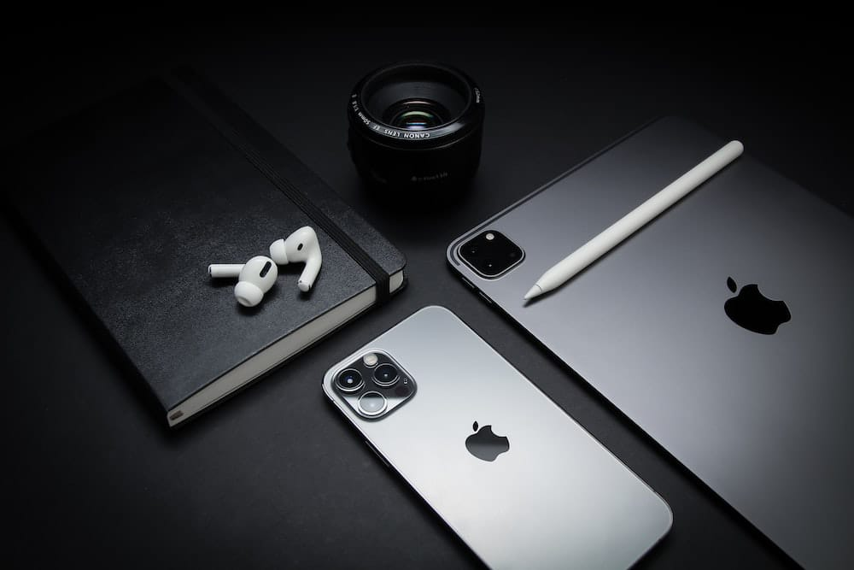

**5.APPLICATIONS**

The world has changed as a consequence of the increasing use of smartphones, which have improved communication, connected people, and revolutionized many different businesses. With its main product, the iPhone, capturing markets around the world, Apple Inc. has emerged as a prominent player among the top smartphone makers. India, one of the economies with the greatest economic growth, has seen a tremendous increase in smartphone usage, making it an interesting market to study the effects of Apple's iPhone.

In order to shed light on important factors like market penetration, customer preferences, economic ramifications, and societal changes, this research report will perform a data-driven investigation of the impact of the iPhone in India.

This study will offer invaluable insights into the transformative impact of the iPhone on India's technological landscape and the lives of its consumers by using advanced data analytics techniques and analyzing large datasets.

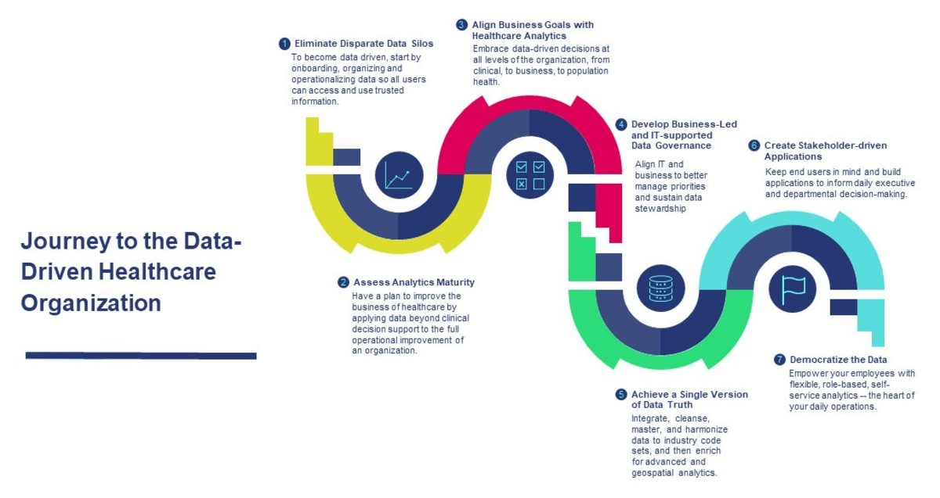

**iPHONE SALES :**

Since the release of Apple’s iPhone on June 29, 2007, it has sold an astounding four million units (Carew, 2008). The hype surrounding its release helped it become the fourth most popular handset in the U.S., and by the end of the October, Apple reported selling 1.12 million units. Additionally, it has become AT&T’s most popular handset, commanding nearly 13 percent of its overall sales (Appleinsider, 2007). During Apple’s 2008 Macworld keynote address Jobs announced that the iPhone had a 19.5 percent share of the smart phone market in the same quarter (Carew, 2008). Consumer satisfaction with the iPhone has been significantly higher than its competitors, according to a 2008 ChangeWave survey. Additionally, the survey shows the iPhone is the top choice among those planning to buy a new phone in the next six months (2008). Despite the fears of a looming consumer-led economic recession, Apple executives still believe the goal of selling 10 million iPhones by the end of 2008 is attainable.

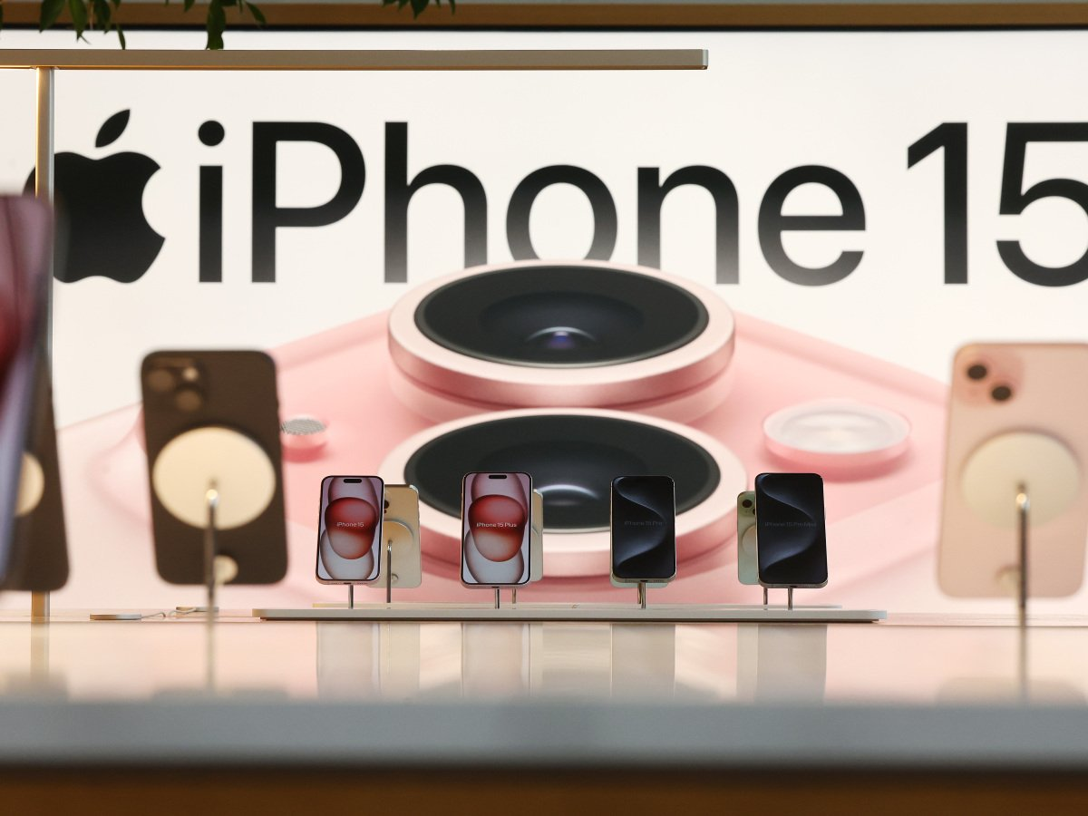

**6.CONCLUTION**

It is irrefutable to say that Apple Inc. is one of the most well-known companies to date. With a huge brand name and consumer base, Apple has been able to target multiple markets simultaneously. The Apple iPhone has successfully been able to satisfy the need for a portable, yet powerful device, that allows the user to access information quickly and efficiently.

First, an environmental scan helped us see some upcoming opportunities and threats for Apple Inc., in terms of psychological and sociocultural influences, we can see that Apple products give target market for the iPhone and using a market-product grid and perceptual map, we can to ages 18-34.

Along with Apple’s brand name, its successful influence on its target market has led them to become the technology giant they are today. Apple shows us a clear lesson on how design thinking and innovation can lead a company to reach greater heights.

Apple has secured the leading position in the competitive market today, and have placed their customers at the heart of the process. Design thinking engages the company to think critically and out of the box. Instead of just taking a problem and using machines to solve it, it allows companies to come up with different solutions and approaches.

**7. FUTURE SCOPE**

The value-creation mechanisms of data analytics, which include using data analytics to: Gain insights (knowledge creation): Data analytics are the technical means to extract insights− and the empowering tools to better understand, influence or control the data objects of these insights (e.g. natural phenomena, social systems, individuals). For example, organisations increasingly rely on simulations and experiments not only to better understand the behaviour of individuals, but in order to better understand, assess, and optimize the possible impact of their actions on these individuals. Automate decision-making (decision automation): Data analytics (through machine learning− algorithms) empower autonomous machines and systems that are able to learn from data of previous situations and to autonomously make decisions based on the analysis of these data. These autonomous machines and systems are getting more and more powerful as they can perform an increasing number of tasks that required human intervention in the past. Google’s driverless car is an illustrative example which is based on machine learning algorithms enriched by data that is collected from the sensors connected to the car and from services such as Google Maps and Google Street View.

**8.APPENDIX**

**Dashboard 1:**

<https://public.tableau.com/views/tableaudashboard1_16978863643750/iRevolution?:language=en-GB&:display_count=n&:origin=viz_share_link>

**Dashboard 2:**

<https://public.tableau.com/views/tableaudashboard2_16978864132490/iRevolution_1?:language=en-GB&:display_count=n&:origin=viz_share_link>

**Story:**

<https://public.tableau.com/views/tableaustory_16978854546820/Story1?:language=en-GB&:display_count=n&:origin=viz_share_link>

**DATA VISUALISATION:**

**KPI:**

<https://public.tableau.com/views/tableauKPI/KPI?:language=en-GB&:display_count=n&:origin=viz_share_link>

**Model specification:**

<https://public.tableau.com/views/tableaumodelspecification/modelspecification?:language=en-GB&:display_count=n&:origin=viz_share_link>

**Battery type distribution:**

<https://public.tableau.com/views/tableaubatterytypedistribution/Batterytypedistribution?:language=en-GB&:display_count=n&:origin=viz_share_link>

**Model share:**

<https://public.tableau.com/views/tableaumodelshare/Modelshare?:language=en-GB&:display_count=n&:origin=viz_share_link>

**Brand price comparison:**

<https://public.tableau.com/views/tableaubrandpricecomparison/Brandpricecomparison?:language=en-GB&:display_count=n&:origin=viz_share_link>

**Country wise best selling smartphones:**

<https://public.tableau.com/views/tableaucuntrywisebestsellingsmartphones/Countrywisebestsellingsmartphones?:language=en-GB&:display_count=n&:origin=viz_share_link>

**Quarterly share:** <https://public.tableau.com/views/tableauquarterlyshare/Quarterlyshare?:language=en-GB&:display_count=n&:origin=viz_share_link>

**Annual Revenue:** <https://public.tableau.com/views/tableauannualrevenue/AnnualRevenue?:language=en-GB&:display_count=n&:origin=viz_share_link>

**KPI_2:**

<https://public.tableau.com/views/tableauKPI_2/KPI_2?:language=en-GB&:display_count=n&:origin=viz_share_link>

**Global market share:**

<https://public.tableau.com/views/tableauGMS/GMS?:language=en-GB&:display_count=n&:origin=viz_share_link>

**VIDEO DEMONSTRATION LINK**